1. Global insurance company allows customers to pay insurance premium with following options

1. Monthly Premium(12)

2. Quarterly Premium(4)

3. Bi Annual(2)

4. Annual(1)

Print total premium paid by 5 different customers.

OUTPUT:

At first menu for insurance premium is listed and the user is asked to enter Customer name, id, plan for investment once he enters all the total sum of that person is displayed below. Similarly enter for all 5 users then finally total sum of all 5 employee’s investment is displayed.

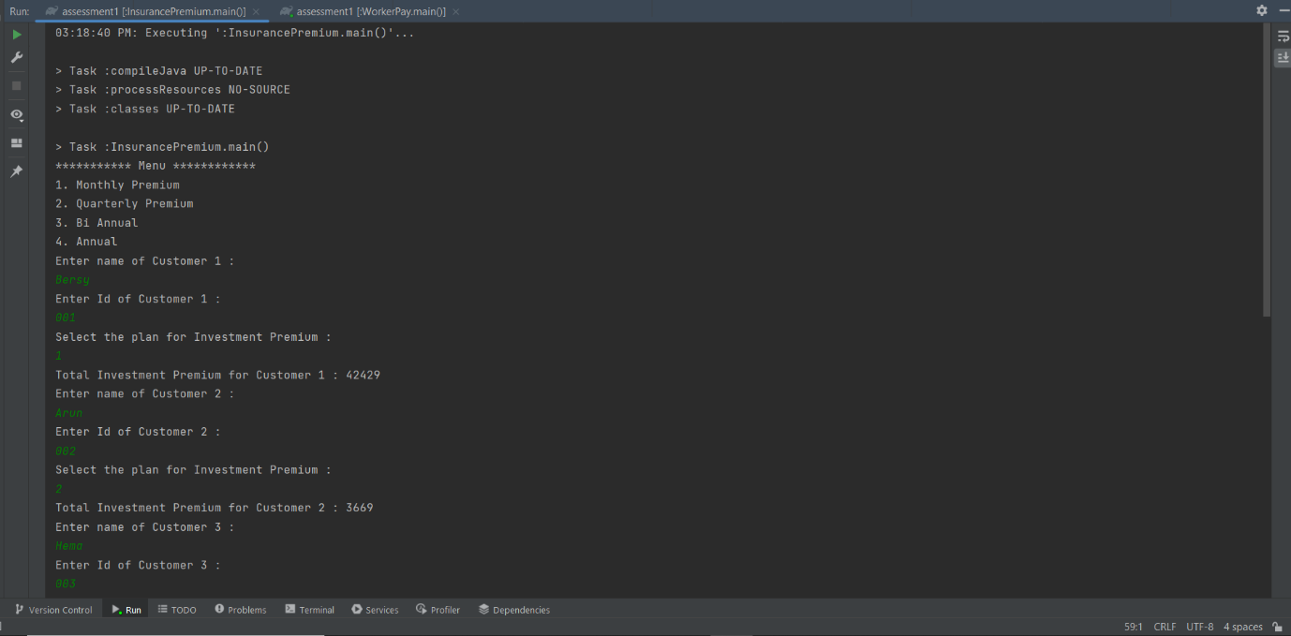

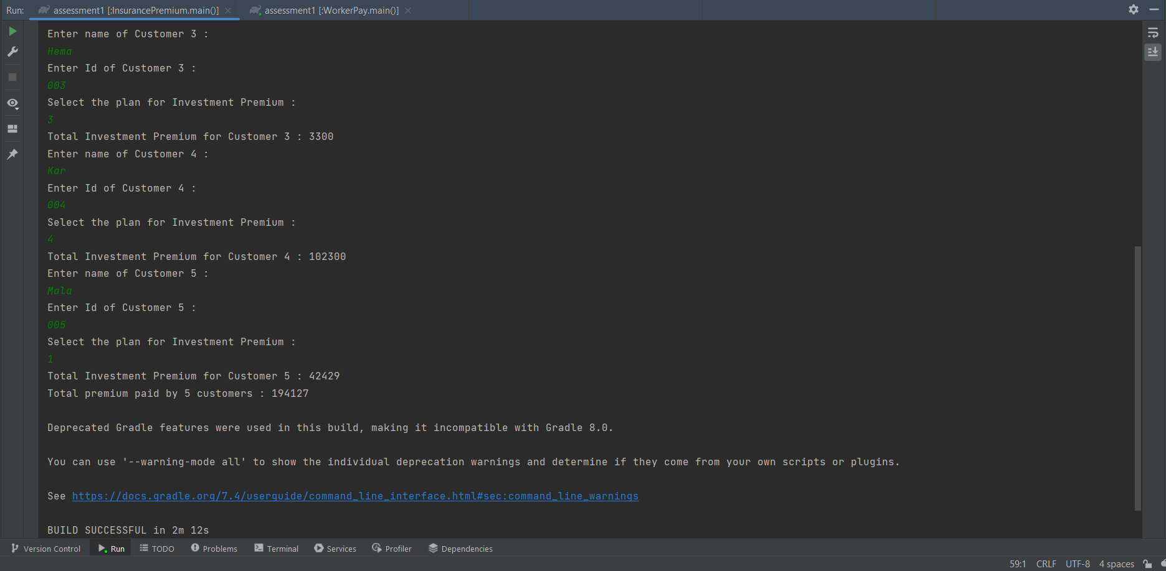

2. Create a class called Employee which asks the user to input the name and the age of a

employee. Raise a custom defined exception when the user enters an employee name

that has been already entered and raise another exception if the age is negative or less

than 18 or greater than 60.

OUTPUT:

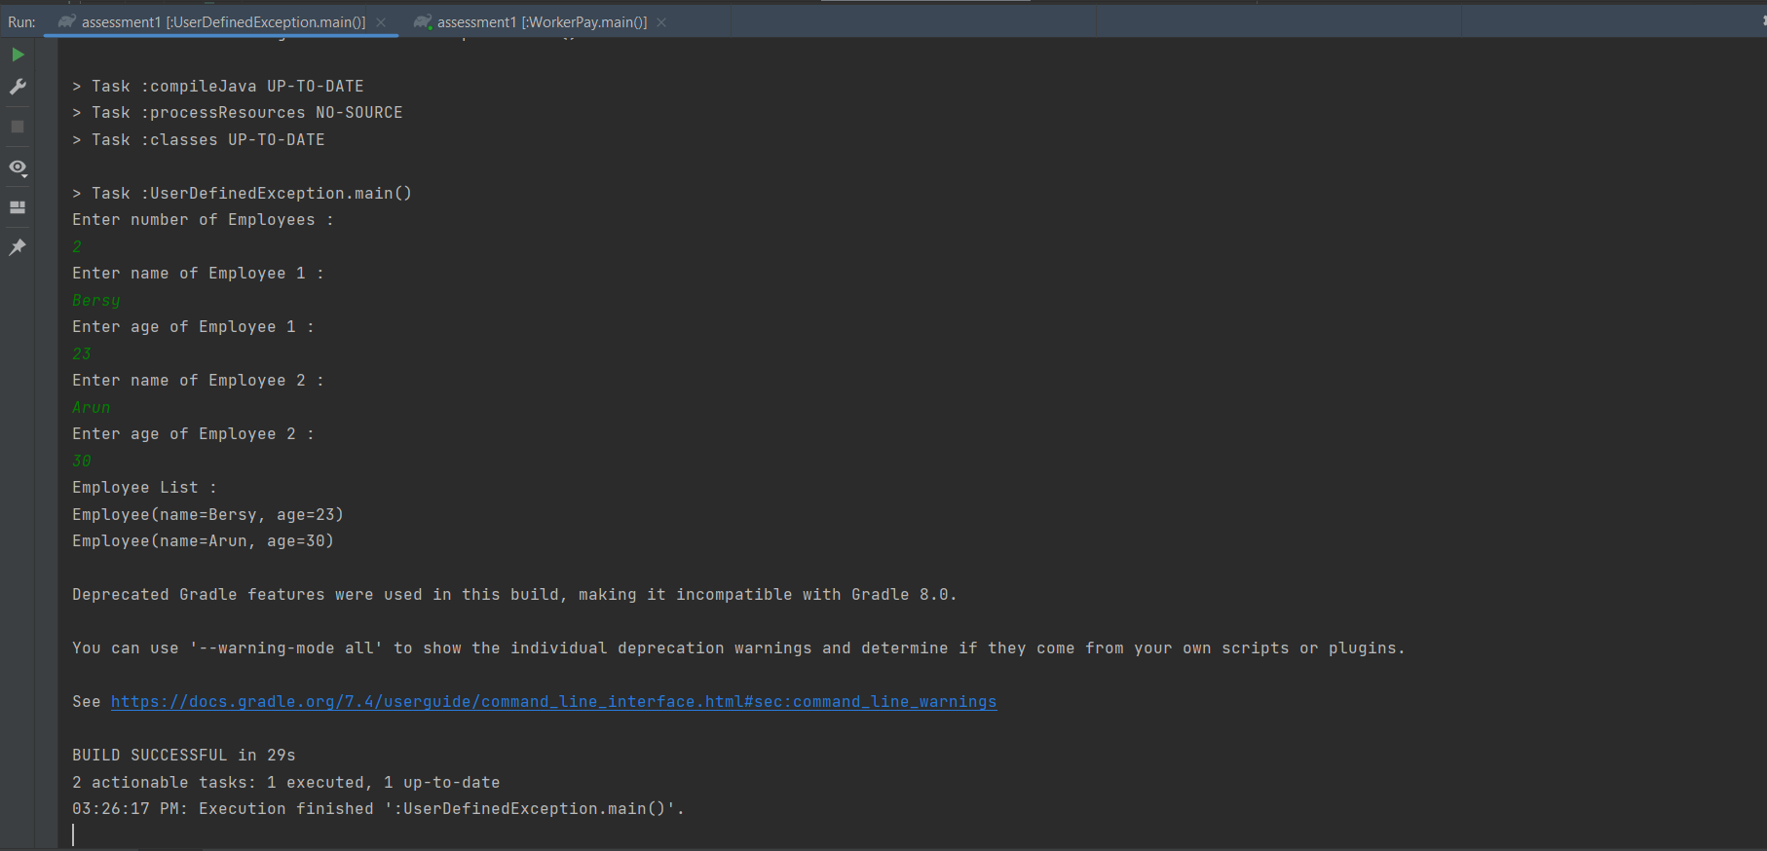When all entered details are correct:

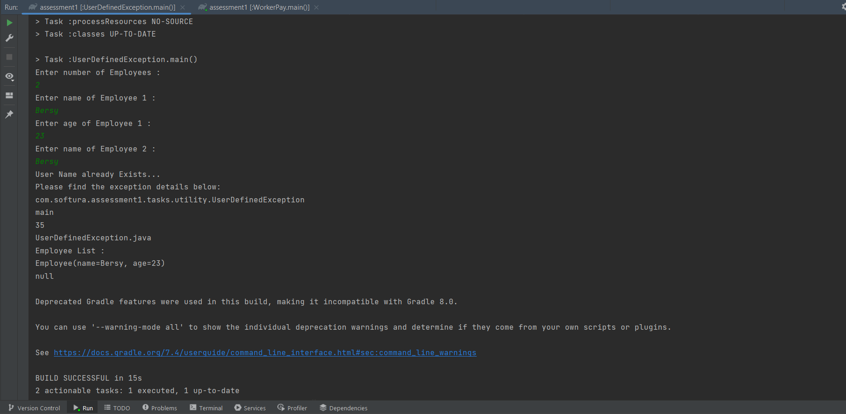When already entered name is entered again:

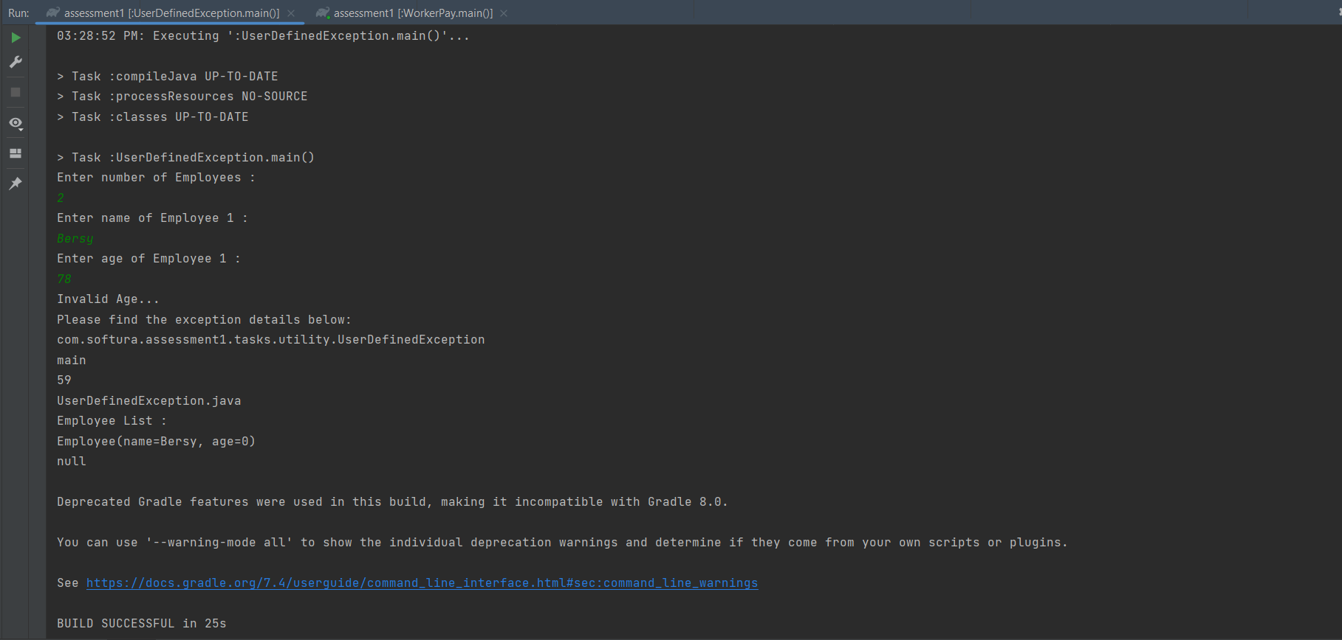When invalid age is entered:

3. Create a class called Worker. Write classes DailyWorker and SalariedWorker that inherit from

Worker. Every worker has a name and a salary rate. Write method Pay (int hours) to compute

the week pay of every worker. A Daily worker is paid on the basis of the number of days

she/he works. The salaried worker gets paid the wage for 40 hours a week no matter what the

actual hours are. Test this program to calculate the pay of workers.

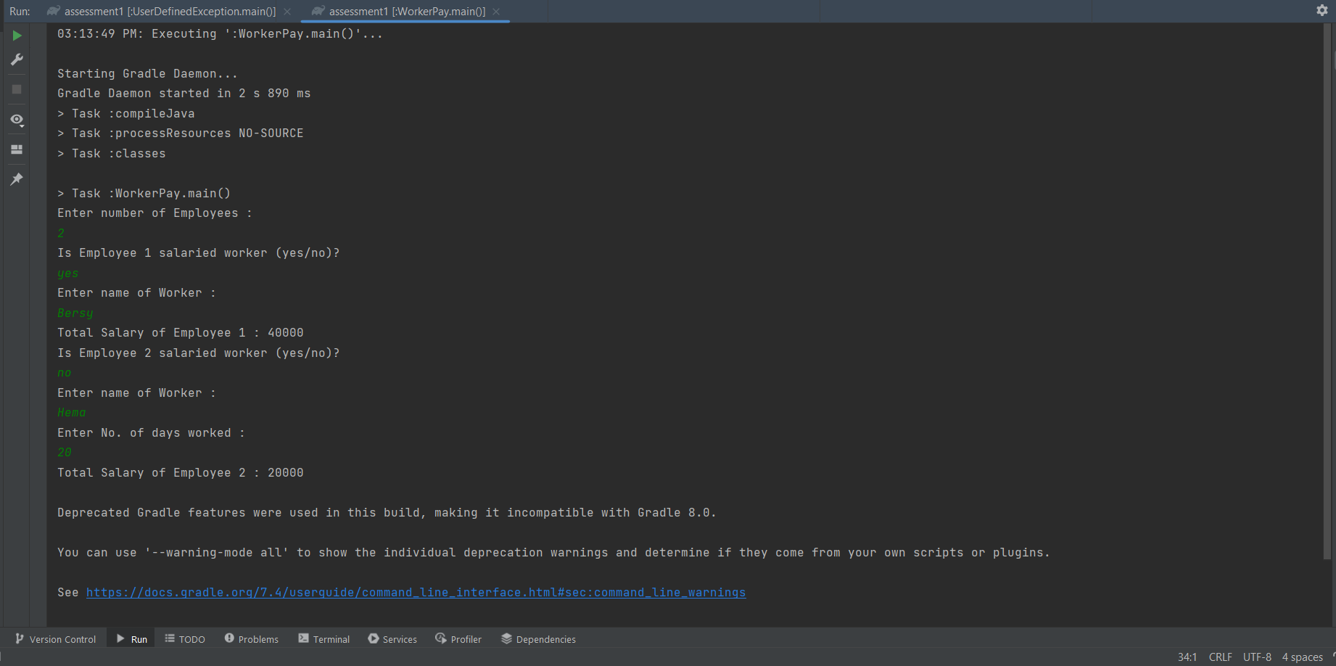OUTPUT:

4. Create the classes required to store data regarding different types of courses that employees

Ina company can enroll for. All courses have name and course fee. Courses are also either

classroom delivered or delivered online. Courses could also be full time or part time. The

program must be menu based input which enables the course coordinator to register

employees for courses, list out employees registered for specific courses, deregister employees

from a course

OUTPUT:

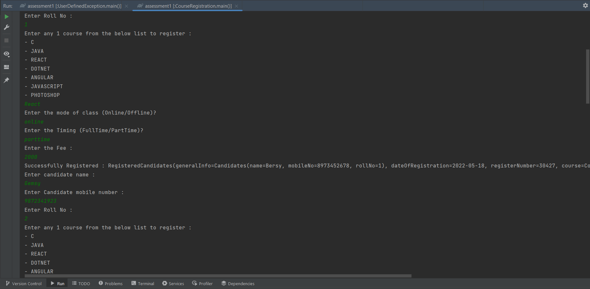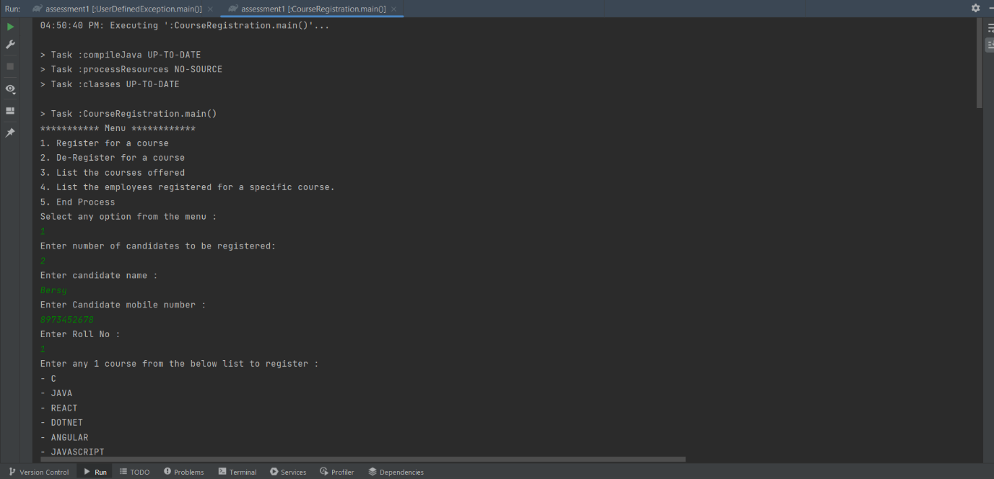Registering for a course:

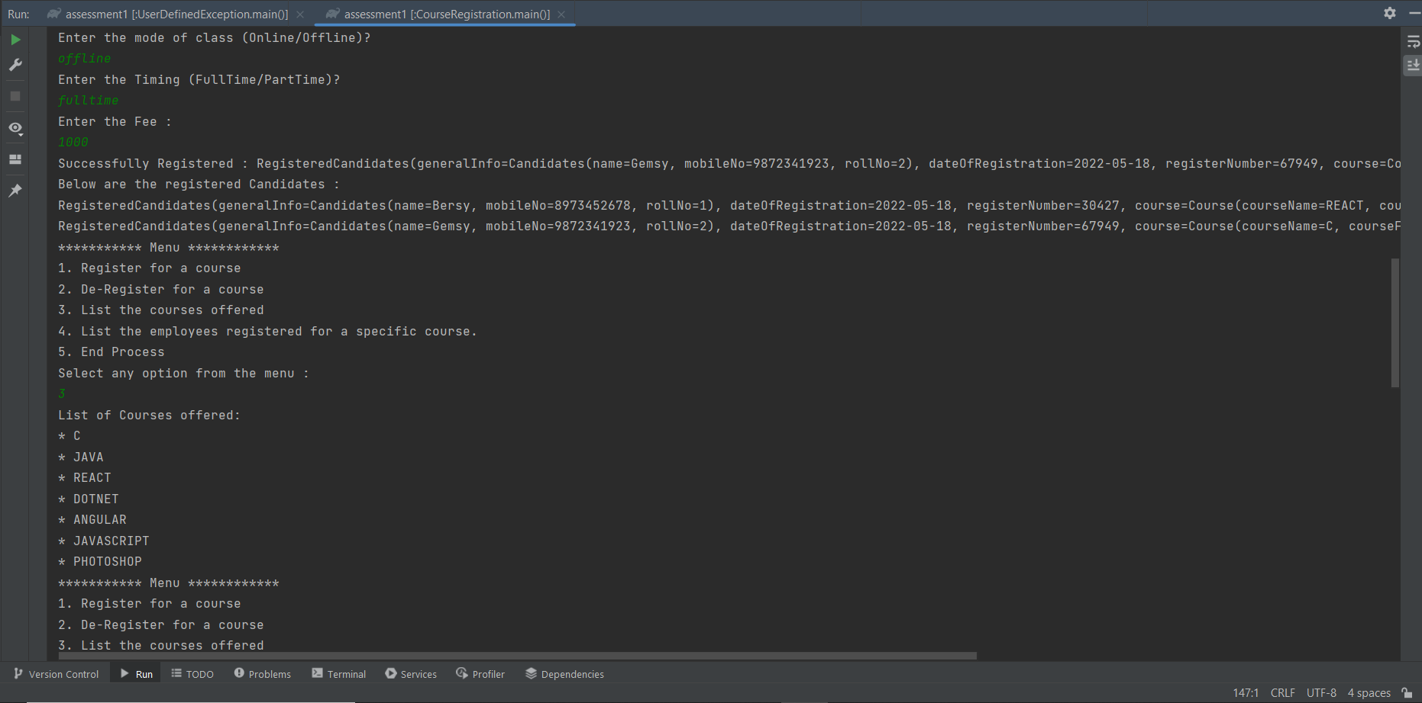List of courses available for registration:

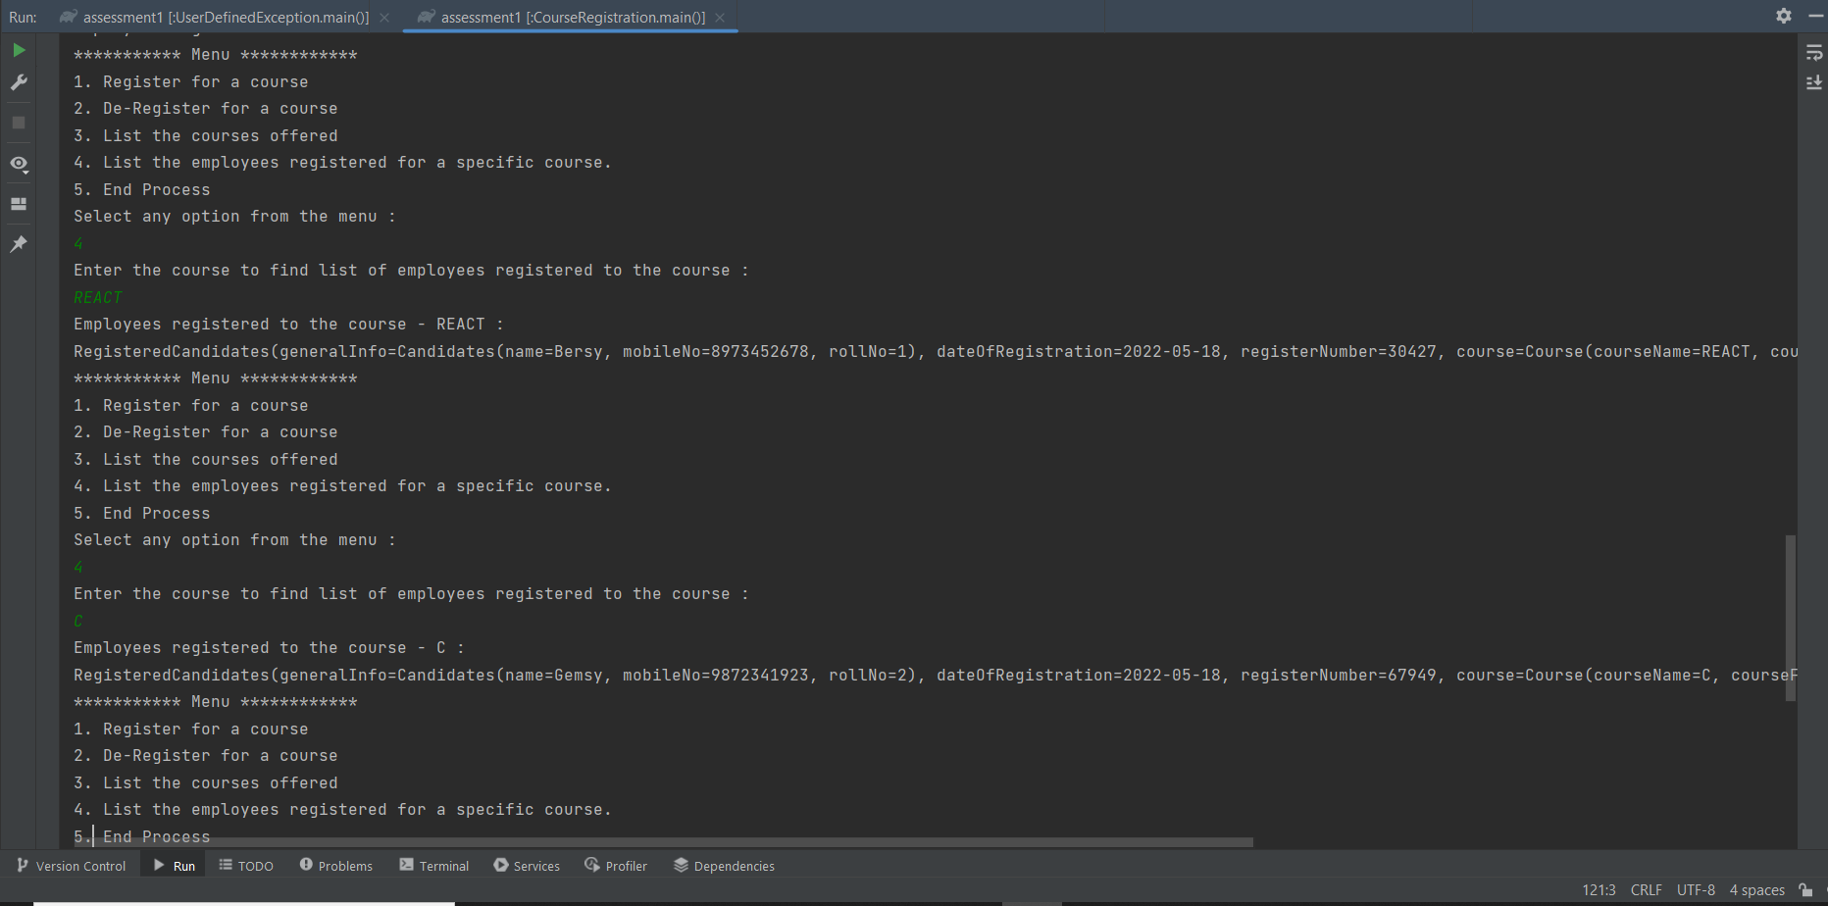Employees registered under a particular course:

De-Registering Candidates:

